Papal cream cake or kremowka. –

One of the best Polish desserts.

Home > Sweet treats > Papal cream cake or kremowka. – One of the best Polish desserts.
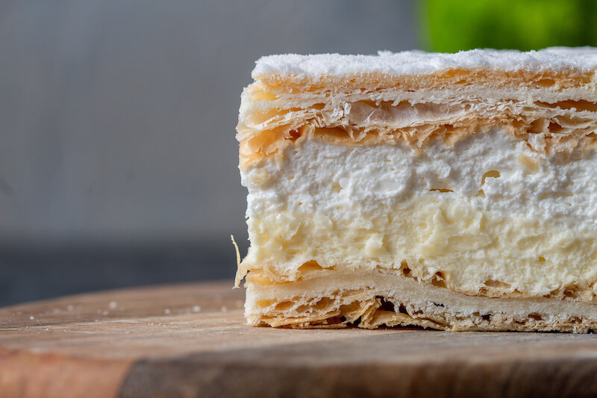
RECIPE BOOK, SWEET TREATS

Papal cream cake or kremowka. – One of the best Polish desserts.

Papal cream cake or kremowka is one of the best Polish desserts ever. Once you try them you will not be able to stop eating them. And btw, the other great Polish dessert is Faworki. It is definitely worth to try.
kremowka, papal cream cake, kremes

And why the name papal cream cake?
According to Wikipedia, it all started back in 1999 when the pope John Paul II talked about his more favorite dessert. The one he ate as a kid in his hometown Wadowice. Yes, you guessed it right, it was the famous cream cake. (actually, that time it was called only – kremowka).
Since then Polish people started to call it the papal – kremowka papieska.

What is the papal cream cake?
The papal cream cake is a Polish dessert made from French puff pastry and vanilla cream filling.
Other versions of the cake are made with whipped cream, vanilla custard, meringue filling or double cream filling. The cake is usually generously sprinkled with powdered sugar and sometimes poured over with sugar icing.
I actually love the version with two layers. It is a combination of the vanilla cream spiced up with a shot of Amaretto (the almond liquor) and the whipped cream.
And if you want to make them just check the recipe below.

How to make the papal cream cake?
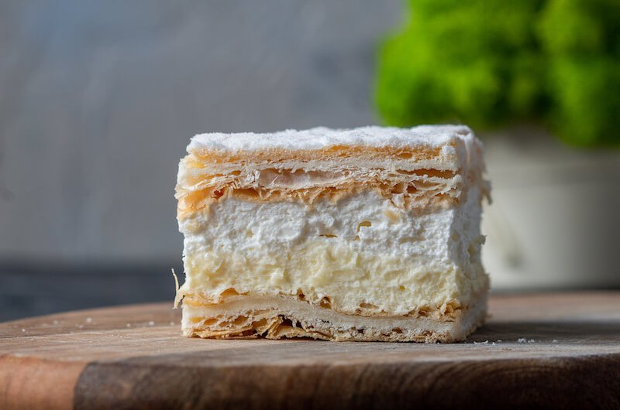
Pin
Print

Papal cream cake – Polish dessert
Recipe by tasteisyoursCourse: DessertCuisine: PolishDifficulty: EasyServings 8- Prep time 2 hours- Cooking time 30minutes Papal cream cake made with vanilla and whipped cream filling.

INGREDIENTS
- 500ml of milk
- 200g of caster sugar
- 1 tsp of vanilla sugar
- 1 tbsp of butter
- 20-40 ml of Amaretto liquor (*optional)
- 6 egg yolks
- 4 tablespoons of potato starch (potato flour)
- 500ml heavy cream (at least with 36% fat)
- 1 tbsp of sugar
- 50g of powdered sugar
- 2 puff pastry sheets

DIRECTIONS
- Bake the puff pastry according the instructions on the package. Set aside.
- Heat up 400ml of milk and add the regular and the vanilla sugar into it. Bring to boil and then lower the heat to low.
- Meanwhile, mix the leftover 100ml milk with the Amaretto and the egg yolks. Add the potato starch one tablespoon at the time and mix well.
- Pour the egg mixture into the hot milk and stir constantly. After a while, the cream should start to thicken. Once it does, turn the heat off and set the cream aside to cool down completely. Once cooled add the butter, this step will help the cream thicken even more so it’s easier to cut later on.
- Beat the heavy cream to whipped cream. *optionally you can add 1 tbsp of sugar at the end to make it bit sweeter.
- Place 1 baked puff pastry sheet on a flat surface and pour on the vanilla cream. Then add the whipped cream on top and cover with the second puff pastry sheet.
- Place the cake into to the fridge for at least one hour.
- Dust the top with the powdered sugar and cut into squares.

NOTES
- You can keep the cake in the fridge for up to 4 days.
- Freezing the cake is not recommended.
- To bake the puff pastry I recommend to use 13 x 9 inches baking tray.
- 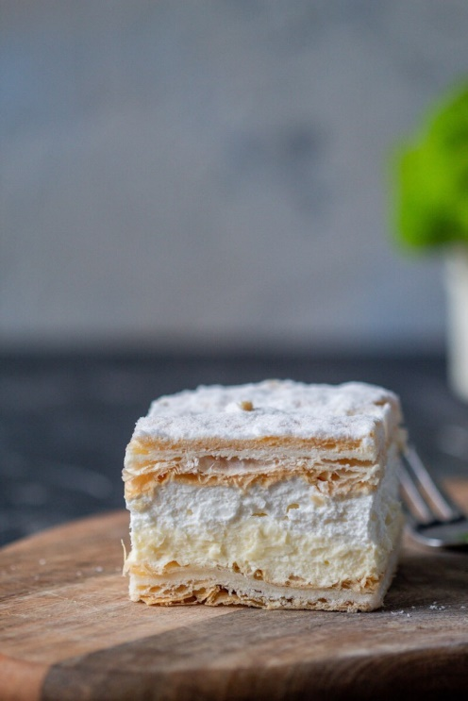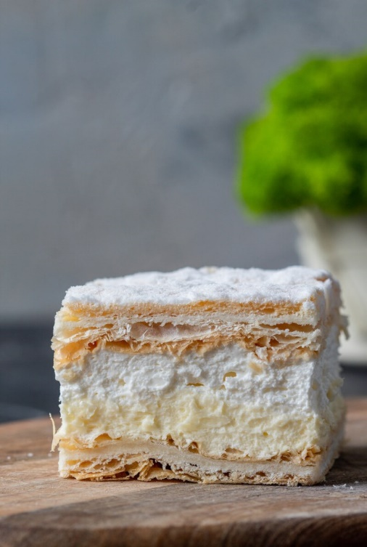

- 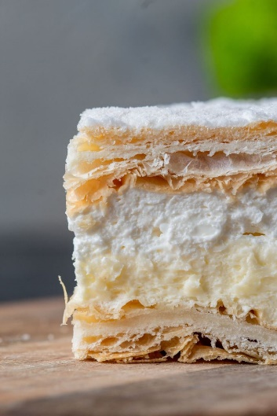

Papal cream cake or kremowka. - One of the best Polish desserts. - https://tasteisyours.com
Papal cream cake or kremowka is one of the best Polish desserts ever. Once you try them you will not be able to stop eating them.
Type: dessert
Cuisine: Polish
Keywords: papal cream cake, kremowka
Recipe Yield: 8
Preparation Time: PT2H00M
Cooking Time: PT0H30M
Total Time: PT2H30M
Recipe Ingredients:
- 500ml of milk
- 200g of caster sugar
- 1 tsp of vanilla sugar
- 1 tbsp of butter
- 20-40 ml of Amaretto liquor (*optional)
- 6 egg yolks
- pinch of salt
- 4 spoons of cornstarch
- 500ml heavy cream (at least with 36% fat)
- 1 tbsp of sugar
- 50g of powdered sugar
- 2 puff pastry sheets
Recipe Instructions: Bake the puff pastry according to the instructions on the package. Set aside. Heat up 400ml of milk and add the regular and the vanilla sugar into it. Bring to boil and then lower the heat to low. Meanwhile, mix the leftover 100ml milk with the Amaretto and the egg yolks. Add the cornstarch one tablespoon at the time and mix well. Pour the egg mixture into the hot milk and stir constantly. After a while, the cream should start to thicken. Once it does, turn the heat off and set the cream aside to cool down completely. Beat the heavy cream to whipped cream. *optionally you can add 1 tbsp of sugar at the end to make it a bit sweeter. Place 1 baked puff pastry sheet on a flat surface and pour it on the vanilla cream. Then add the whipped cream on top and cover with the second puff pastry sheet. Place the cake into the fridge for at least one hour. Dust the top with the powdered sugar and cut into squares.
Editor's Rating:

