THE RELICS OF JOHN PAUL II AND JOHN XXIII DURING THE CANONIZATION WHEN
JOHN PAUL II AND JOHN XXIII
WERE DECLARED SAINTS
ON APRIL 27, 2014
IN VATICAN CITY.
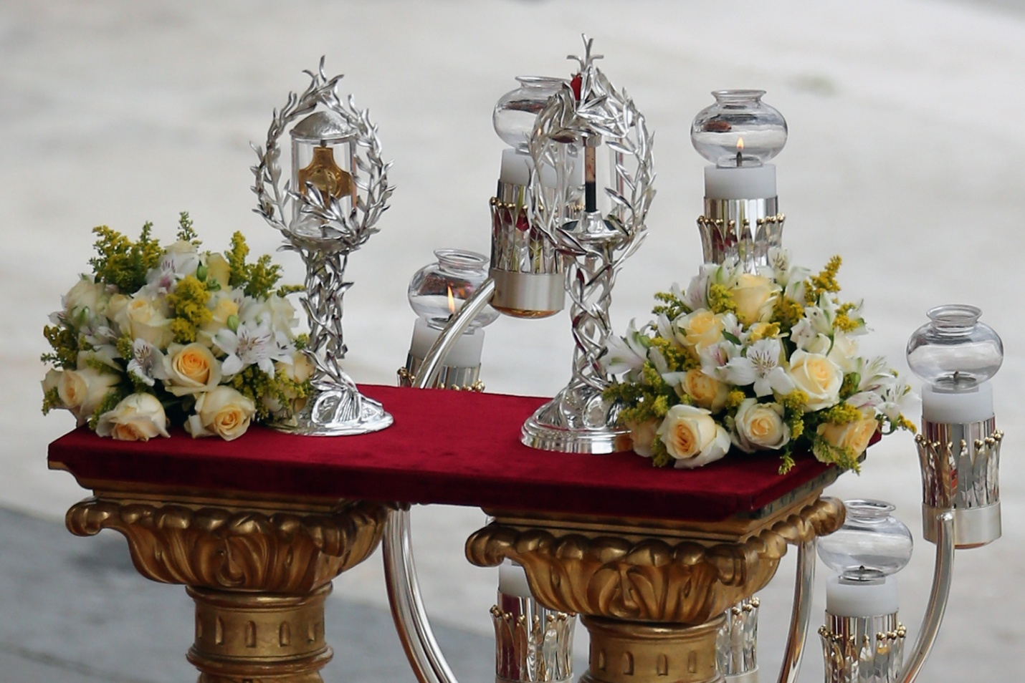
Copyright © 2014 Getty Images. All rights reserved.

