FRIENDS OF THE JOHN PAUL II FOUNDATION,
WASHIGNTON DC CHAPTER
HONORS REVERND MONSIGNOR WALTER R. ROSSI,
RECTOR OF THE BASICILIA OF THE SHRINE OF THE IMMACULATE CONCPETION, WASHINGTON DC.
CONTACT: Cecilia Glembocki - Friends of John Paul II Foundation Washington DC Chapter 703 501 6152

On May 19, 2018, the Friends of the John Paul II Foundation, honored the Reverend Monsignor Walter R. Rossi, rector of the Basilica of the Shrine of the Immaculate Conception in Washington DC at the Army Navy Country Club in Arlington, VA.
The event was a celebration of the remembrances of Pope Saint John Paul II ‘s 98 th. birthday.
By celebrating his birthday, the Foundation honored Monsignor Rossi with a crystal cube of the images of St. John Paul II and Monsignor Rossi. The crystal cube was placed on a lighted base to illuminate the images. Monsignor was pleased and spoke about his Polish heritage and the significance it meant to him. He reminisced about John Paul II and his encounters with him and the importance of His presence in Washington DC.
The Foundation praised Monsignor Rossi for his dedication to the Altar of our Lady of Czestochowa in the Basilica and for planning so many memorable moments remembering the life and works of our Beloved saint. The Foundation’s purpose is to preserve the legacy of Saint John Paul. They reach out to three diocesan school systems by working with the religious educators who disseminate thousands of pieces of educational materials all about St. John Paul II. The committee is busy at work creating opportunities for teachers and schools to receive posters, medals, leaflets about the Interesting Facts of the Life of John Paull II, Leaflet on the meaning of Relics especially those about John Paul II. Lesson plans are specifically developed for these religious educators who teach our children and influence their minds and spirit. Lesson plans were developed by Carol Jones, a curriculum specialist who developed these turn key programs for the Foundation. The latest lesson plan for the book beautifully illustrated about John Paul II - At the Altar of the World Book has been distributed to more than 3,500 students, teachers and media centers in the greater Metropolitan area. Washington DC Baltimore and Arlington Counties. It’s a turn key program developed specifically for educators to teach directly from this book. It is with the greatest hope of the DC Chapter of the Foundation to share the enthusiasm so many of us who have shared, a moment with Him, who met Saint John Paul, those dined with him, share the Eucharist with him, walked beside him and realized now that this indeed was a rare opportunity to have met a saint. He inspired us with His dignity of life, He taught us how to live life in the presence of God, to respect and dignify life itself. May we share His memory for generations to come by our work on behalf of the Friends of the John Paul II Foundation. Currently there are 49 Foundation chapters which exit in 17 countries on five continents.
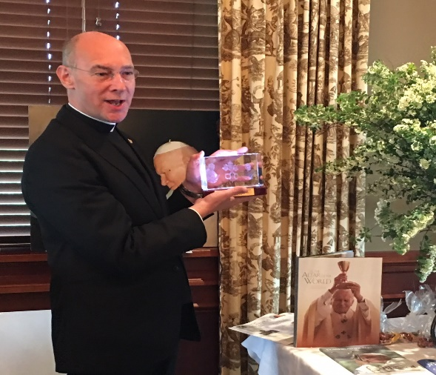 Monsignor Rossi receiving the crystal Cube.

Children at St Veronica’s school each received a book about John Paul II, 3,500 of these books were distributed to three diocesan school systems through our Foundation.
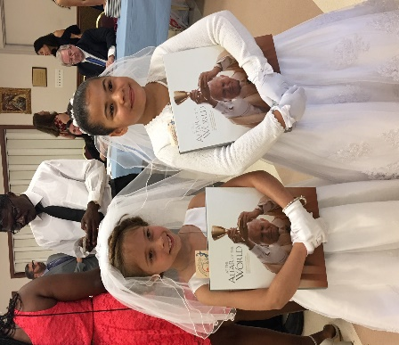

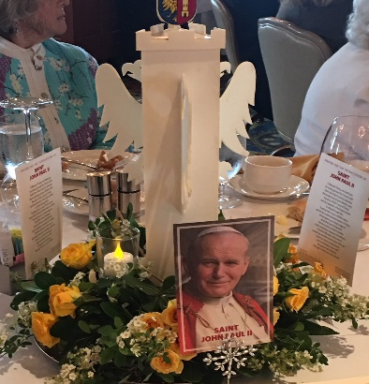
center pieces honoring John Paul II -Wadowice castle the birthplace of JPII

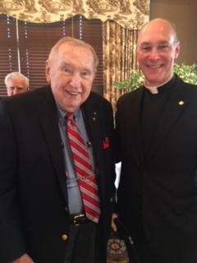President Richard Wiermanski and Monsignor Rossi.
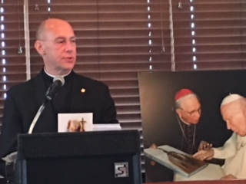Monsignor Rossi remembering his Polish Heritage.

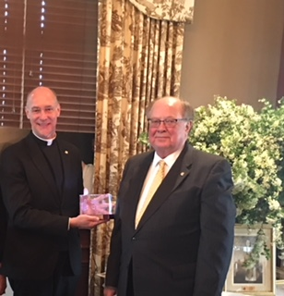Monsignor Rossi and Master of Ceremonies- Raymond Glembocki past president of the Foundation in Washington DC

